**5) Setup VPC End Point**

🡪Go to, end point in vpc console 🡪 name the tag 🡪select AWS services in service category

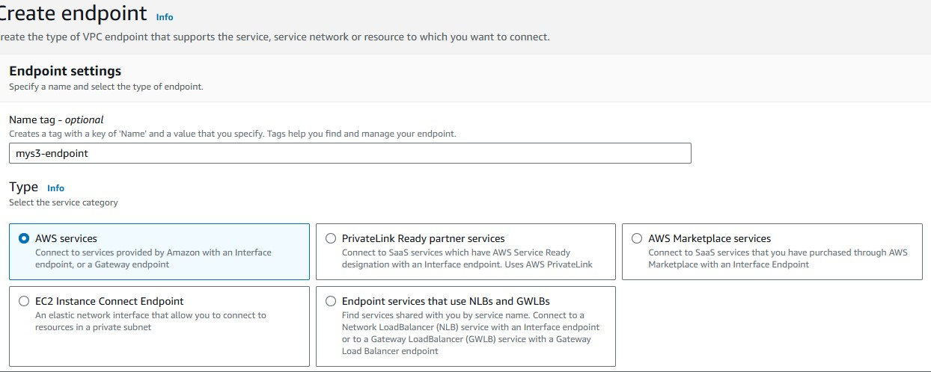

🡪 In network setting, search for s3 select the s3 with region

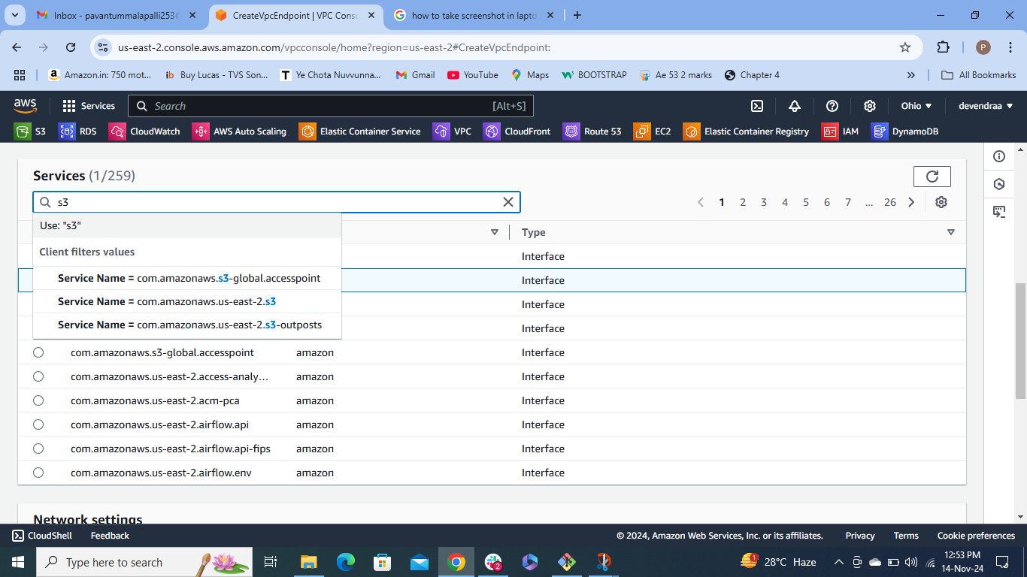

* Select gate way
* Select vpc id that you created
* Select private route table

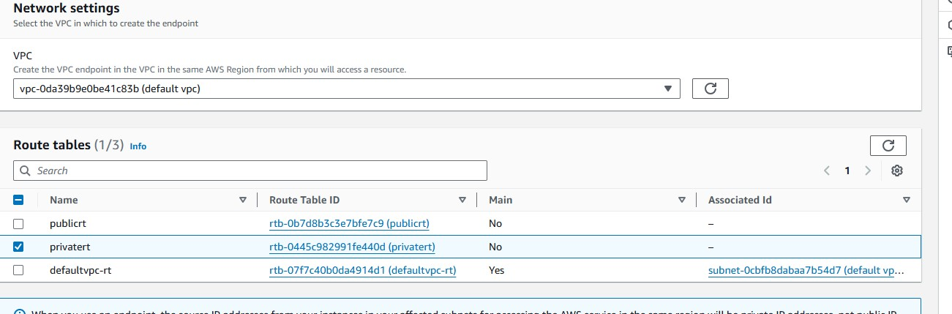

* Create end point

**Open Ec2-instance**

* Launch the instance
* Give the command as

|  |
| --- |
| * aws config |

🡪give the access key and secret key that will generated in aws console

🡪open aws website 🡪 go to security credentials 🡪below create a access key, create access key 🡪 it will generate a access key and secret key 🡪 copy and paste it in the local server.

Giv the command as aws s3 ls to check the s3 bucket

|  |
| --- |
| Run aws s3 ls |